Chapter 1. An Introduction to Ansible
Automating Tasks with Ansible
Quiz: Automating Tasks with Ansible
Configuring Your Ansible Development Environment
Guided Exercise: Configuring Your Ansible Development Environment
Configuring Ansible Settings
Guided Exercise: Configuring Ansible Settings
Summary
Abstract
Goal | Describe the fundamental concepts of Ansible and how it is used, install and configure Ansible development tools in VS Code, and configure Ansible settings.
Sections | - Automating Tasks with Ansible (and Quiz)  - Configuring Your Ansible Development Environment (and Guided Exercise)  - Configuring Ansible Settings (and Guided Exercise)
Automating Tasks with Ansible
Objectives
- Review the motivation for automating tasks with Ansible, fundamental Ansible concepts, and the basic architecture of Ansible.
Automating Manual Tasks with Ansible Automation
Manual approaches to system deployment and configuration often lead to errors, missed steps, and inconsistencies, causing significant delays and operational inefficiencies.
These challenges can cause the following problems:
- Downtime due to misconfigurations or failed deployments, caused by human error
- Less time for critical tasks due to slow and error-prone manual processes
- Difficulty in scaling operations
- Slow response to changing business needs due to slow manual processes
- Inability to quickly roll out new features or updates
Ansible automation provides an agentless automation platform that enables you to automate repetitive tasks, manage configurations, and deploy applications consistently and reliably. Ansible automation directly addresses the challenges with manual approaches by enabling you to achieve the following goals:
- Automate repetitive tasks, reducing the risk of human error.
- Gain more time for you to focus on more critical work.
- Simplify management of complex environments, making it easier to scale operations.
- Respond more quickly to changing business needs by automating manual processes.
- Deploy application versions and updates significantly faster, accelerating innovation and improving responsiveness.
Infrastructure as Code
A good automation system, such as Ansible, facilitates Infrastructure as Code (IaC). IaC means defining and describing the desired state of your infrastructure using a human-readable automation language. This code is then applied to ensure that the infrastructure is in the desired state.
The Ansible automation language is written in simple text files, so it can be managed in a version control system, providing a history of changes and enabling easy reversion to earlier configurations. This foundation helps you to follow DevOps best practices, allowing you to define configurations and to deploy them reproducibly.
Mitigating Human Error
Reducing manual tasks through automation and IaC ensures more consistent system configurations. When you implement Ansible automation, you must update automation code as needed, and have a good process for code review and version management. Ultimately, enforcing changes through automation and following good development practices mitigates human error.
What Is Ansible?
Ansible is an open source automation platform. It is a simple automation language that accurately describes the application infrastructure in Ansible Playbooks, and an automation engine that runs these playbooks. Ansible handles powerful automation tasks and adapts to many workflows and environments; new users can quickly become productive.
Ansible is simple
- Ansible Playbooks provide human-readable automation, making them easy to comprehend and change without special coding skills.
- Their simplicity enables every team to use them, enabling quick productivity for new users.
Ansible is powerful
- Ansible can be used for application deployment, configuration management, workflow automation, and network automation, orchestrating the entire application lifecycle.
Ansible is agentless
- Ansible is built around an agentless architecture.
- It connects to managed hosts (typically via OpenSSH or WinRM) and runs tasks by pushing out small programs called Ansible modules.
- These modules set the system to a desired state and are removed after tasks are finished.
- This agentless approach means faster setup, greater efficiency, and better security than alternatives.
Key Features of Ansible Playbooks
Feature | Description
Cross-platform support | Agentless support for Linux, Windows, UNIX, and network devices across physical, virtual, cloud, and container environments.
Human-readable automation | Ansible Playbooks, written in text, are easy to understand and allow for easy interoperability between multiple teams.
Precise application descriptions | Every change and aspect of the application environment can be described and documented in playbooks.
Easy to manage in version control | Playbooks are plain text, and can be treated like source code in version control.
Support for dynamic inventories | Managed machine lists can be dynamically updated from external sources.
Orchestration integration | Integrates with systems such as HP SA, Puppet, and Jenkins.
A Brief History of Ansible
Ansible is a powerful open source automation platform that simplifies tasks such as configuration management, application deployment, and orchestration. It was created by Michael DeHaan in 2012, with the goal of providing a simple, agentless, and easy-to-use automation tool. Its name, Ansible, is from science fiction, referencing instantaneous communication across vast distances.
Its rapid adoption led to the founding of Ansible, Inc. (originally AnsibleWorks, Inc.) in 2013. In October 2015, Red Hat acquired Ansible, integrating it into their enterprise offerings.
Ansible Components and Versions
Ansible's core components are packaged and distributed separately.
Ansible Core
The ansible-core package provides Ansible Core, which is the fundamental engine containing the Ansible language and runtime, core command-line tools such as ansible and ansible-playbook, and essential modules. It has its own versioning scheme, for example: 2.15, 2.16.
Ansible (Community Package)
The Ansible community package includes ansible-core as well as a large collection of community-maintained modules and plug-ins. It has its own release cycle.
Before Ansible version 2.10, Ansible was distributed as a single package containing the Ansible engine and core tools, such as the ansible-playbook command and a wide array of modules and plug-ins. This "batteries included" approach presented several challenges:
- Infrequent updates: New modules and plug-ins were only available with major Ansible releases, typically every 3-6 months.
- Bloated packages: Users received all content, even if they only needed specific parts.
- Version rigidity: It was difficult for users to get specific versions of content independently of the Ansible engine.
To address these issues, Ansible was redesigned and is now released in two formats:
Ansible Core
- Originally released as ansible-base up until version 2.10, then the name was changed to ansible-core for versions 2.11 and later.
- Provides the minimal, fundamental Ansible engine and core tools.
- Users install desired modules and plug-ins separately as Ansible content collections. Ansible content collections are packages of Ansible content, including modules, plug-ins, roles, and documentation.
Community Ansible
- Continues the "batteries included" approach by shipping with a selection of popular content collections.
- Users can still install additional content collections not included in the main package.
Figure 1.1: History of Ansible Core and Community Ansible
Red Hat Ansible Automation Platform
Red Hat Ansible Automation Platform is Red Hat's enterprise-grade, subscription-based product. It builds on community Ansible, adding a web-based UI and API for centralized management, role-based access control, logging, and advanced features for large-scale enterprise automation.
It includes the automation controller component (formerly Ansible Tower), which is used for managing and scaling automation tasks across teams and environments. Red Hat Ansible Automation Platform offers enterprise support and curated content.
The Red Hat Ansible Automation Platform versioning aligns with the Ansible Core versioning. For example:
- Ansible Automation Platform version 2.4 is based on Ansible Core 2.15
- Ansible Automation Platform version 2.5 is based on Ansible Core 2.16
Ansible development tools
Ansible development tools are a set of command-line tools that provide an enhanced, consistent experience for Ansible content creators. Ansible development tools are not a separate product, but rather a set of tools that are included with Ansible Core and Community Ansible. They are designed to help you create, test, and manage Ansible content more efficiently.
In this course, we use Ansible development tools integrated with VS Code to create and test Ansible content.
Ansible Concepts and Architecture
The following diagram illustrates the architecture of Red Hat Ansible Automation Platform 2.5.
The Ansible architecture consists of two types of machines: control nodes and managed hosts. Ansible is installed and run from a control node, and this machine also has copies of your Ansible project files. Managed hosts are the systems that Ansible manages and configures.
The control node communicates with managed hosts over SSH for Linux/UNIX systems, WinRM for Windows systems, using these protocols to execute tasks and gather information. For network devices, Ansible can use various connection methods, such as SSH or API calls, depending on the device's capabilities.
The agentless architecture of Ansible eliminates the need for a specific agent or additional communication configuration on managed hosts.
Ansible Playbooks, Plays, Tasks, and Modules
Ansible users create one or more plays that define a desired state for hosts. These plays are written in YAML in a text file called a playbook. A play runs a series of tasks in order.
Each task runs one or more modules, which are small scripts or programs with defined arguments that performs specific actions. These actions ensure that a particular aspect of a machine is in a desired state, such as a file existing with specific permissions, or a file system is being properly mounted.
A playbook can contain multiple plays, and each play can target different hosts or groups of hosts.
If a task fails, Ansible typically aborts the rest of the playbook for the failing hosts, although this behavior can be modified.
Ansible Inventory
Ansible uses an inventory to specify the hosts that it manages. The inventory can be a static file or dynamically generated from an external source. It lists the managed hosts and can group them logically, allowing you to target specific groups in your playbooks.
The Benefits of Idempotency
Tasks, plays, and playbooks are designed to be idempotent, meaning they can be run multiple times without making changes if the system is already in the correct state.
Ansible also uses plug-ins to extend and adapt it. Plug-ins are pieces of code that augment Ansible's core functionality, such as connection methods, inventory sources, or output formatting.
Getting Support for Ansible
Red Hat Ansible Automation Platform is a fully supported enterprise version of Ansible for large-scale automation. It offers the following benefits:
- Official support for core Ansible tools
- Red Hat Certified Ansible Content Collections for faster adoption
- On-premise tools for centralized content delivery, task management, and execution scaling
- Cloud services for certified content discovery, team collaboration, and operational analytics
Ansible Use Cases
The Ansible Way
Ansible's design goals emphasize the following ideas:
Design goal | Description
Complexity kills productivity | Simplicity in tools, writing, and reading automation.
Optimized for readability | Automation language built on simple, declarative, text-based files for clear workflow documentation.
Think declaratively | A desired-state engine that puts systems into the desired state by only making necessary changes, rather than acting like a scripting language.
Ansible combines orchestration with configuration management, provisioning, and application deployment:
Configuration Management
Centralizing configuration file management and deployment.
Application Deployment
Defining applications with Ansible and managing deployment with automation controller for the entire application lifecycle.
Provisioning
Streamlining system provisioning (Preboot execution environment (PXE) booting, kickstarting bare-metal, creating VMs/cloud instances).
Continuous Delivery
Creating CI/CD pipelines with a simple automation platform usable by all teams, ensuring proper application deployment throughout the lifecycle.
Security and Compliance
Defining security policy to integrate scanning and remediation into automated processes.
Orchestration
Defining how multiple configurations interact and manage disparate pieces as a whole.
Ansible and Containers
Ansible can run within containers and is commonly used to manage containerized environments or deploy applications into containers. For example, Ansible can install Docker or Podman, manage containers, or deploy applications to Kubernetes.
Ansible and Terraform
Ansible and Terraform are powerful automation tools with different primary purposes that often complement each other.
Terraform Infrastructure as Code (IaC)
Excels at provisioning and managing infrastructure (virtual machines, networks, databases) across cloud providers and on-premise environments. It uses a declarative language (HCL) and maintains a state file to track infrastructure against its defined configuration.
Ansible (Configuration Management and Application Deployment)
Excels at configuring existing infrastructure and deploying applications. After Terraform provisions a VM, Ansible can install software, manage services, configure user accounts, and deploy applications. It is agentless, using SSH for Linux/UNIX and WinRM for Windows.
Complementary Workflow
The most common pattern is using Terraform for "Day 0" operations provisioning infrastructure and Ansible for "Day 1" and "Day 2" operations configuring and managing applications. Terraform outputs can dynamically create Ansible inventory, allowing Ansible to configure the newly provisioned machines. This combined approach automates the entire infrastructure lifecycle.
References
Ansible
How Ansible Works
Red Hat Ansible Automation Platform
Introducing Ansible Automation Platform 2
Releases and Maintenance - Ansible Documentation
Configuring Your Ansible Development Environment
Objectives
- Install and configure an Ansible development environment by using the Ansible development tools.
Ansible Development Tools
Ansible development tools are a suite of officially supported tools included in every Red Hat Ansible Automation Platform subscription. Use these tools to create a more consistent and efficient automation development lifecycle, because they provide a standardized way of creating, testing, and managing your Ansible automation content.
Ansible development tools enable you to focus more on developing automation content, and less on the configuration and maintenance of your Ansible development environment.
The following list includes the key development tools included in the Ansible development tools suite:
Ansible lint (ansible-lint)
The ansible-lint command checks your Ansible automation content for common errors and deprecated coding standards, so that they can be corrected before your content is committed to source control and deployed to production. This helps to ensure code quality, reducing the risk of errors when the automation content is run against production systems.
Automation content navigator (ansible-navigator)
The ansible-navigator command provides an intuitive tool that enables you to run and test your Ansible content within self-contained automation execution environments. This makes it easier to troubleshoot your Ansible automation content.
Execution environment builder (ansible-builder)
The ansible-builder command enables you to create customized and portable automation execution environments. You can create and share custom automation execution environments to provide a consistent way to develop, test, and run automation content across different systems, from a local laptop to a production automation controller.
Ansible development tools are seamlessly integrated into the Visual Studio Code (VS Code) integrated development environment (IDE), by using the official Ansible extension for VS Code. The official Ansible extension brings the functionality of the development tools directly into the feature-rich environment of the IDE, which helps streamline the development workflow.
Note
Ansible development tools contain several tools that help automate the development process, improve code quality, and streamline collaboration among team members.
You use a subset of these tools in this course, focusing on the tools that are most relevant for Ansible Playbook development.
VS Code for Ansible Playbook Development
VS Code is a powerful IDE for creating Ansible Playbooks because its core functionality can be extended and customized to meet the needs of an automation developer. The Ansible and Dev Containers extensions for VS Code enhance the Ansible automation development experience.
The Ansible extension
The Ansible extension for VS Code provides help with best practices by integrating directly with ansible-lint for real-time error checking and best-practice enforcement. The extension can also connect to Ansible execution environments to provide more accurate feedback.
The Dev Containers extension
The Dev Containers extension for VS Code enables you to run your entire development environment inside a container. In the case of Ansible automation content development, the Dev Containers extension enables you to use the Ansible development tools container image to create a containerized development environment.
Source control integration
VS Code also has native support for essential development workflows such as source control, also known as version control, through the use of Git. Source control management is a cornerstone of modern software development, and is seamlessly integrated into the VS Code editor through its built-in Git capabilities. This allows you to track changes, manage branches, commit code, and resolve merge conflicts through an intuitive graphical user interface without ever leaving the editor. This tight integration allows for a more efficient workflow when managing Ansible automation code in a remote repository.
Syntax highlighting
VS Code provides syntax-specific features that improve the process of reading and writing Ansible's YAML syntax through the use of syntax highlighting. Syntax highlighting helps distinguish between keys, values, strings, and comments, using different text colors in the editor, making the structure of complex playbooks visually easier to navigate.
Code completion
Another powerful feature in VS Code is IntelliSense, which provides intelligent code completion. As you type, the editor offers context-aware suggestions for module names, parameters, and even variable names, significantly reducing human errors and the time spent consulting documentation.
Configuring an Ansible Development Environment in VS Code
Configuring VS Code to use the Ansible development tools requires installing both the Ansible and Dev Containers extensions in VS Code. In VS Code, click the Extensions icon in the Activity Bar (on the left side of the application window), or click View → Extensions to display the Extensions view in the Side Bar. Search for the Ansible extension in the search bar and click Install.
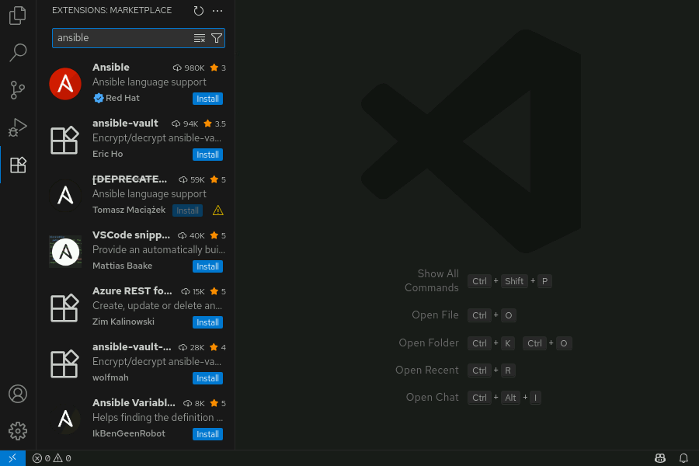
Figure 1.3: Installing the Ansible extension
Search for the Dev Containers extension in the search bar and click Install.
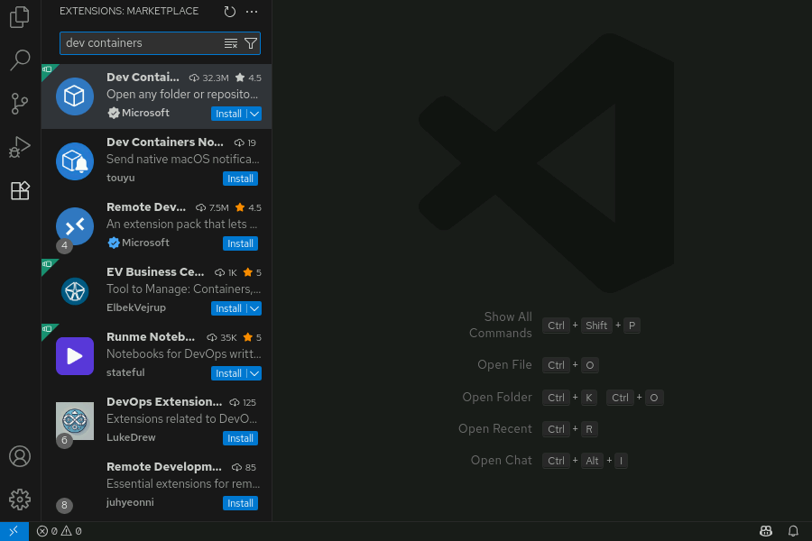
Figure 1.4: Installing the Dev Containers extension
In VS Code, click the Explorer icon in the Activity Bar, or click View → Explorer to display the Explorer view in the Side Bar. Click the Open Folder button to select and open the directory that contains the Ansible project, alternatively you can click the Source Control icon in the Activity Bar to clone a Git repository if the Ansible project files reside in a remote Git repository.
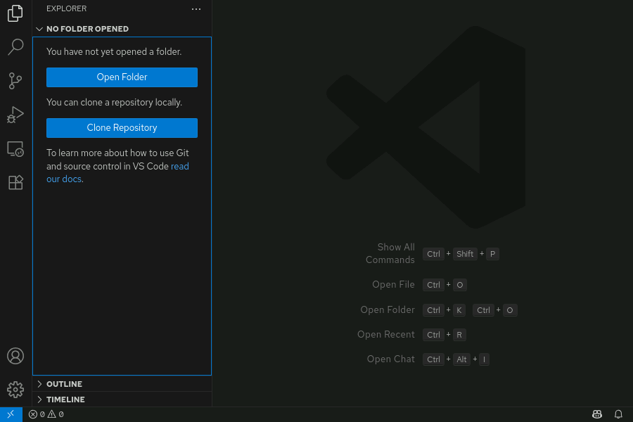
Figure 1.5: Opening the project directory
In VS Code, click the Ansible icon in the Activity Bar, and then click Settings to view the settings for the Ansible extension.
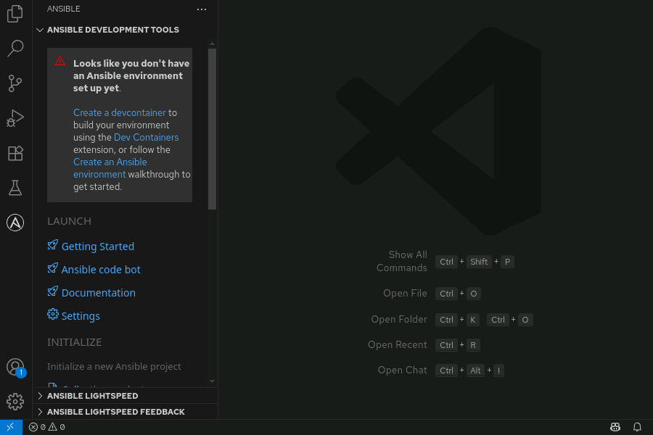
Figure 1.6: Opening Ansible extension settings
In the Settings pane check the boxes for the Ansible > Validation > Lint:Enabled and Ansible > Execution Environment: Enabled options to enable Ansible lint and the use of automation execution environments in your development environment.
In VS Code, click the Extensions icon in the Activity Bar, and then click the Manage button represented by the gear icon on the Dev Containers extension to open the settings for the Dev Containers extension. Alternatively you can right click the Dev Containers extension and click Settings to view the extension settings.
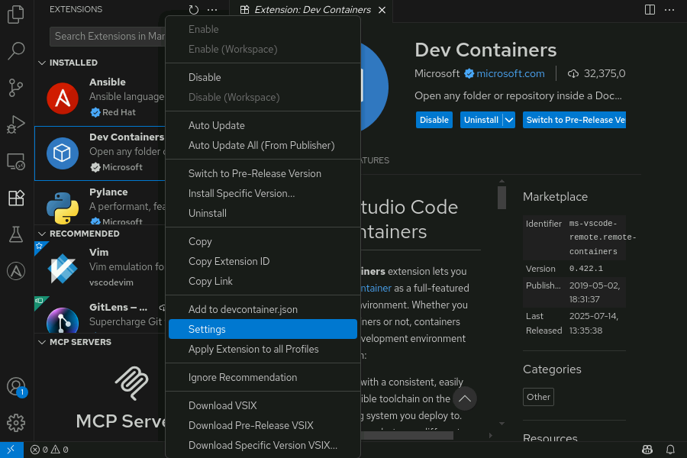
Figure 1.7: Opening Dev Containers extension settings
In the Settings pane change the value for the Dev › Containers: Docker Compose Path setting to podman-compose and change the value for the Dev › Containers: Docker Path setting to podman to configure the Dev Containers extension to use Podman for the container engine.
In VS Code, click the Ansible icon in the Activity Bar to display the Ansible extension view in the Side Bar and click Devcontainer under the ADD section to configure the new development container.
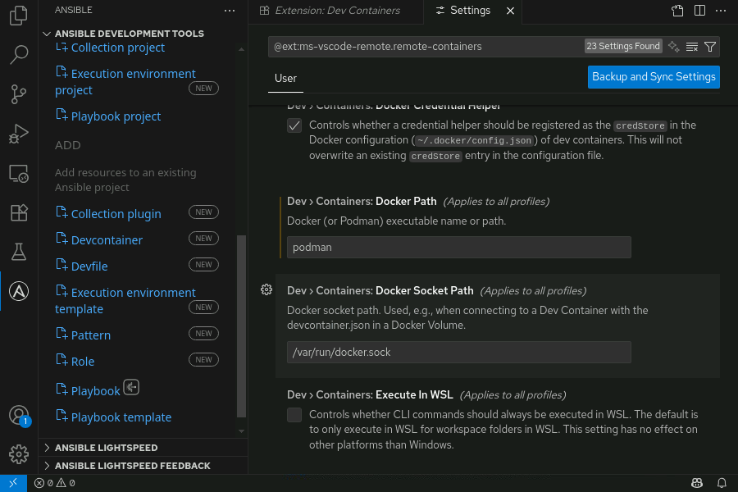
Figure 1.8: Creating development container
In the Create Devcontainer pane Select the Downstream image for the Container image and then click Create.
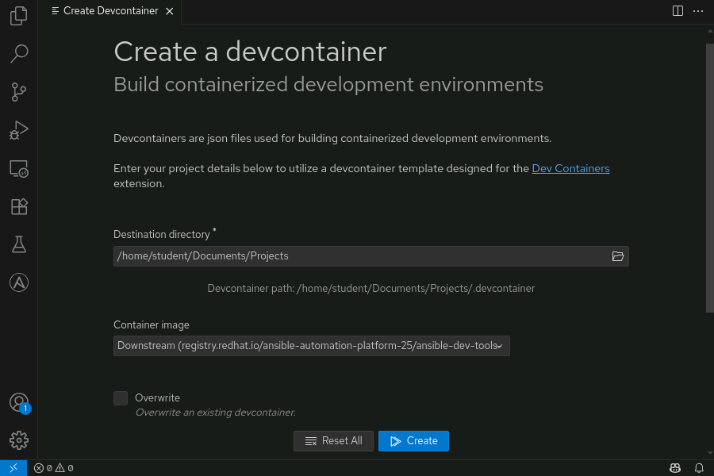
Figure 1.9: Creating development container from downstream image
This process creates the .devcontainer directory in the root directory of your project. Access to the registry.redhat.io/ansible-automation-platform-25/ansible-dev-tools-rhel8 downstream image is included in your Red Hat Ansible Automation Platform subscription.
You might want to host the container image in a container registry on your local network. Inside the .devcontainer directory is the podman/devcontainer.json file that contains settings for the development container.
You can change the value for the image key in the devcontainer.json file to specify a different image or image location for the development container. The following example demonstrates how to change the development container image to the my-registry.com/user/ansible-dev-tools-rhel8:latest image:
{
"name": "ansible-dev-container-podman",
"image": "my-registry.com/user/ansible-dev-tools-rhel8:latest",
"containerUser": "root",
"runArgs": [
...output omitted...
After the .devcontainer directory has been created, if the container registry hosting the development container image requires authentication, then open a terminal and run the podman login command to log in to the remote registry. Close and reopen VS Code, the Dev Containers extension detects the .devcontainer directory and VS Code prompts to ask you to Reopen in Container in the lower-right corner of the VS Code window.
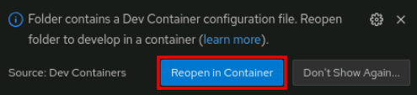
Figure 1.10: Reopening in development container
Click Reopen in Container and then select the ansible-dev-container-podman file to use the settings and container image specified in the .devcontainer/podman/devcontainer.json file.
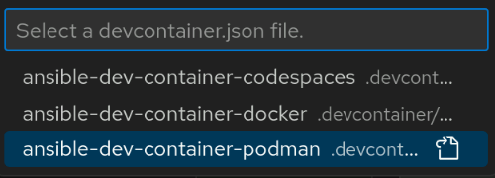
Figure 1.11: Selecting JSON file
When the remote connection to the development container is established, the lower-left corner of the VS Code window shows the status.
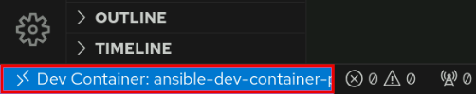
Figure 1.12: Container connection status
The Ansible project directory is now mounted inside of the development container in the /workspaces directory. You can now use the Ansible development tools in the development container to create and test your Ansible Playbooks.
Using Ansible Development Tools to Run an Ansible Playbook
After you create an Ansible Playbook in your project, you can use automation content navigator to run the playbook in the development container. Right click your playbook in the file explorer and then click Run Ansible Playbook Via…​ → Run playbook via 'ansible-navigator run'.
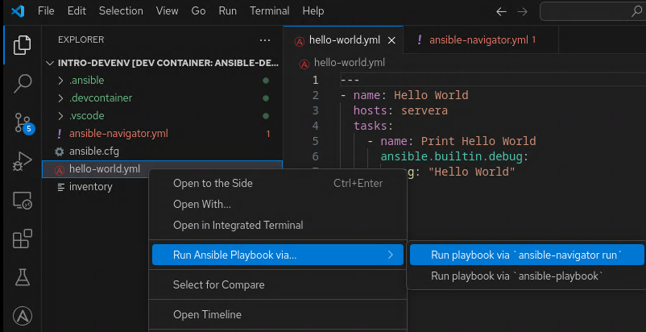
Figure 1.13: Running Ansible Playbook
A terminal window pane opens and displays the output of the playbook run.
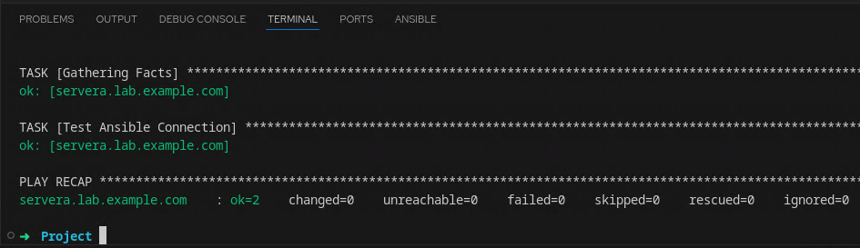
Figure 1.14: Ansible Playbook output
Using Git to Manage Project Files
Git is a distributed version control system (DVCS), which enables you to collaboratively manage changes to files.
Using Git provides many benefits:
- You can review and restore earlier versions of files.
- You can compare two versions of the same file to identify changes.
- You can record a log of who made what changes, and when those changes were made.
- Users can collaboratively modify files, resolve conflicting changes, and merge the changes.
Using Git, you can start by cloning an existing shared project from a remote repository. Cloning a project creates a complete copy of the original remote repository as a local repository. This local copy has the entire history of the files in Git, and not just the latest snapshot of the project files.
You make edits to files in a working tree, which is a checkout of a single snapshot of the project. Next, you add the modified files to a staging area, ready to commit the changes to the local repository. At this point, no changes have been made to the shared remote repository.
When you are ready to share the completed changes, you commit and then push the changes to the remote repository.
Likewise, when you are ready to update the local repository with the latest changes to the remote repository, you pull the changes, which fetches them from the remote repository and merges them into the local repository.
To use Git effectively, you must be aware of the three possible states of files in the working tree: modified, staged, or committed.
State | Description
Modified | The file in the working tree is different from the latest version in the repository.
Staged | You have added the modified file to a list of changed files to commit, but the staged files have not been committed yet.
Committed | You have committed the modified file to the local repository.
Initial Git Configuration
Because Git users often modify projects with multiple contributors, Git records the user's name and email address on each of their commits. You can define these values at a project level, but you can also set global defaults for a user. The git config command-line utility controls these settings.
Using git config with the --global option manages the default settings for all Git projects to which you contribute by saving the settings in your ~/.gitconfig file:
user@host:~$ git config --global user.name 'Peter Shadowman'
user@host:~$ git config --global user.email peter@host.example.com
Cloning a Git Repository
One way to clone a Git repository in VS Code is to open the Source Control view in the Side Bar by clicking the Source Control icon in the Activity Bar. The Activity bar is the navigation bar on the left side of the application window. You can also open the Source Control view by selecting View → Source Control, or pressing the Ctrl+Shift+G keyboard shortcut.
When you are in the Source Control view, click Clone Repository.
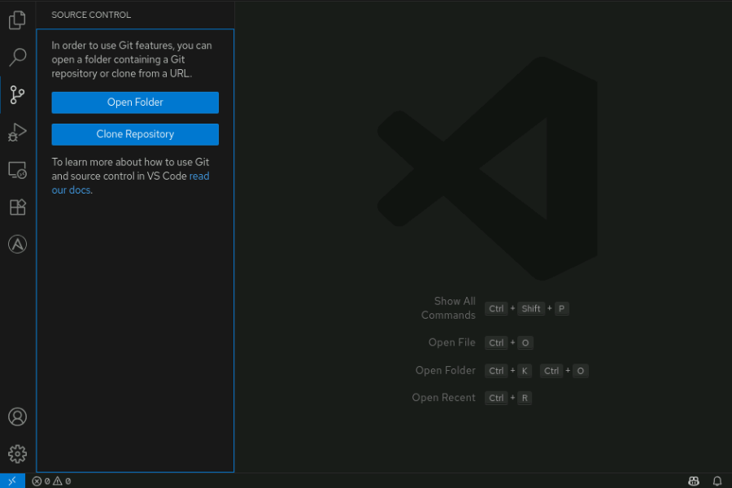
Figure 1.15: Cloning a repository in VS Code
You can also clone a Git repository in VS Code by using the Command Palette, which you can access by selecting View → Command Palette, or by pressing Ctrl+Shift+P or F1 on the keyboard.
In the Command Palette, type Git: Clone to access the Git clone feature. The Command Palette prompts you for the URL of the remote Git repository.
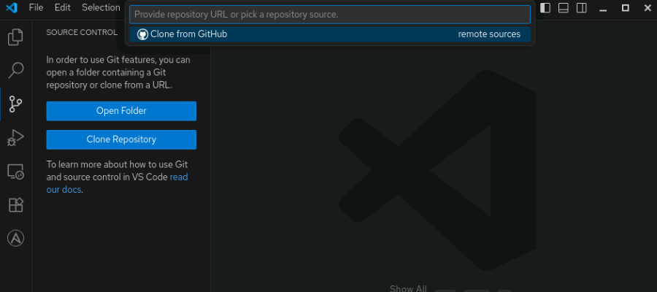
Figure 1.16: Cloning Git repositories using the Command Palette
Staging Changed Files for Commits
As you work, you create files and modify existing files in the working tree. This changes the working tree to a dirty state, which means that it contains modifications which have not been committed to the current branch.
To view staged files in VS Code, click the Source Control icon in the Activity Bar.
To include a file in the next commit, click the plus sign (+) next to the name of the file in the Source Control view to add the file to the Staged Changes section. Click the minus sign (-) to remove changed files from the Staged Changes section.
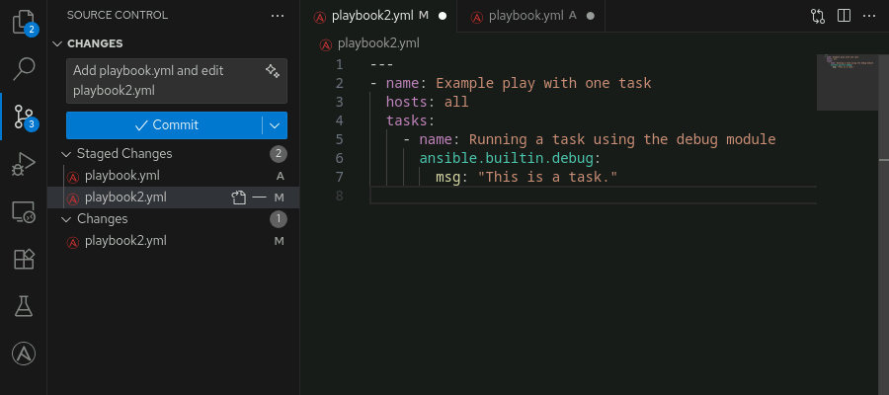
Figure 1.17: Staging changes in VS Code
Note that an uppercase A appears next to added files, and an uppercase M appears next to modified files.
Committing Staged Files to the Git Repository
To commit your staged changes, type a commit message in the message box and then click Commit. This saves your changes to the local Git repository.
Commit messages do not have to be long, but they should be meaningful so that they are useful.
Note
Meaningful and concise commit messages are the key to maintaining a clear history for an Ansible project. Use descriptive commit messages and add references to issues, tickets, and related people where applicable.
Synchronizing Changes
The common way to coordinate work with Git is for all developers to push their work to the same, shared, remote repository. This is also how you provide your Ansible automation code to automation controller.
You push to upload commits you made in your local repository to the remote repository. To push your changes to the remote repository using VS Code, click the Source Control icon in the Activity Bar to display the Source Control view, and then go to More Actions(…​) → Push. Alternatively, click More Actions(…​) → Pull,Push → Push.
Likewise, you pull to download changes to your local repository from the remote repository. When you pull from a remote repository, you perform three operations:
- Fetch commits from the remote repository.
- Add those commits to the local directory.
- Merge changes into the files in the working tree.
To pull changes from the remote repository when using VS Code, click More Actions → Pull. Alternatively, click More Actions → Pull,Push → Pull.
Pull often to stay current with the changes that other developers might be making to the project in the remote repository.
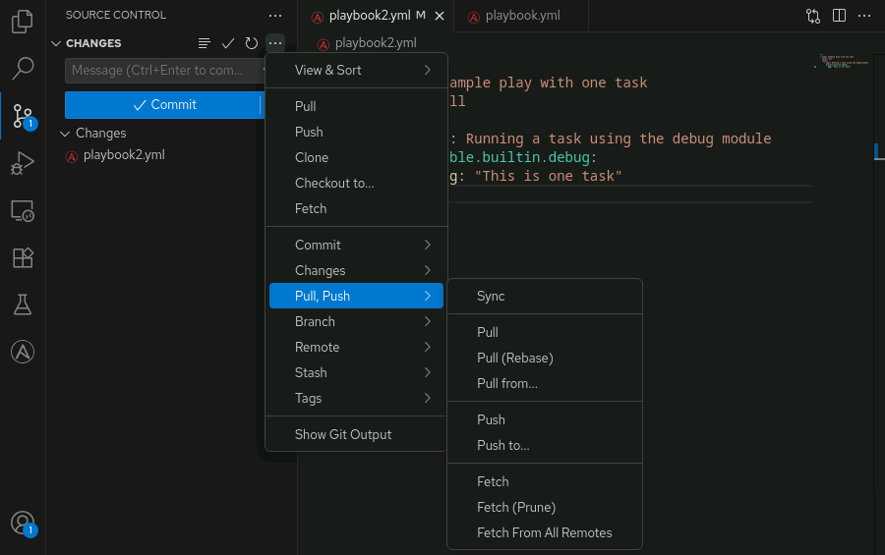
Figure 1.18: Synchronizing local changes with a remote repository
Note
There is also an action on the Status Bar, in the lower-left corner of the VS Code application window, that can be used to synchronize changes. Clicking it pulls changes from the remote repository, then pushes your changes to the remote repository.
References
Introduction to Git in VS Code
Get Started with the Ansible Visual Studio Code Extension
Developing Inside a Container
Ansible Development Tools
Configuring Ansible Settings
Objectives
- Configure Ansible settings by modifying Ansible configuration files.
Creating Configuration Files
Ansible requires that some configuration settings be specified before you can run Ansible Playbooks. These settings control how Ansible connects to managed hosts, performs privilege escalation, and other behaviors. You can set these configuration settings by using environment variables, command-line options, and configuration files.
Using configuration files is a common and effective way to manage configuration settings, especially for projects that involve multiple contributors. Create and manage the following two configuration files to set Ansible configuration settings:
- ansible.cfg, which configures the behavior of several Ansible tools.
- ansible-navigator.yml, which configures default options for the ansible-navigator command.
These configuration files should be placed in the root directory of your Ansible project directory structure:
user@host:~/project$ tree .
.
├── ansible-navigator.yml
├── ansible.cfg
├── inventory
└── playbook.yml
...output omitted...
Managing Ansible Settings
Create an ansible.cfg configuration file in each of your Ansible project directories. The Ansible configuration file consists of several sections, with each section containing settings defined as key-value pairs. Section titles are inside brackets.
For basic operation, use the following two sections:
- [defaults], which sets the default values for Ansible operation
- [privilege_escalation], which configures how Ansible performs privilege escalation on managed hosts
The following example shows an ansible.cfg configuration file:
[defaults]
inventory = ./inventory
remote_user = user
ask_pass = false

[privilege_escalation]
become = true
become_method = ansible.builtin.sudo
become_user = root
become_ask_pass = false
The inventory parameter specifies the path to an inventory file, or to a directory containing multiple inventory sources.
The remote_user parameter specifies the username that Ansible uses to connect to the managed hosts. In a containerized automation execution environment run by the ansible-navigator command, the default value for this setting is root.
The ask_pass parameter specifies whether to prompt for an SSH password. The default value for this setting is false. Set this parameter to true for password-based SSH authentication, or to false for SSH public key authentication.
The become parameter specifies whether to automatically switch users on the managed host (typically to root) after connecting. The default value for this setting is false. Although you can enable privilege escalation for all plays by setting this parameter to true, you might decide to only enable privilege escalation on the plays, roles, blocks, or tasks that require elevated privileges.
The become_method parameter specifies how to switch users. The default value for this setting is ansible.builtin.sudo, although other methods, such as ansible.builtin.su, are available.
The become_user parameter specifies which user to switch to on the managed host. The default value for this setting is root.
The become_ask_pass parameter specifies whether to prompt for a password for the become_method parameter. The default value for this setting is false.
Configuration File Locations and Precedence Order
Configuration requirements vary across environments and projects, so Ansible uses a layered configuration model. Ansible searches for configuration files in several predefined locations and uses the first file it finds according to a specific order of precedence.
This approach provides the following benefits:
- You can define system-wide defaults that apply to all users and projects.
- You can customize user configuration settings that override system defaults.
- You can apply configuration settings for a project that override both user and system settings.
- You can temporarily override all settings by specifying an environment variable that points to a specific configuration file.
Understanding this precedence order ensures that your configuration settings work as expected. When the same parameter appears in multiple locations, the value in the highest precedence configuration file takes effect.
The following table shows the locations where Ansible searches for configuration files, ordered from the highest to the lowest precedence:
Generating a Sample Ansible Configuration File
Instead of creating the file manually, you can generate a sample Ansible configuration file automatically by using the ansible-config command.
The following command creates a file named ansible.cfg in your current working directory and includes all configuration parameters. It comments out every configuration setting so that Ansible can use the default values until you uncomment and customize the settings that you want to override.
user@host:~/project$ ansible-config init --disabled > ansible.cfg
This approach can be helpful to quickly see all configurable options in one place and use the file as a reference when fine tuning Ansible behavior.
Alternatively, you can use the ansible-navigator command to generate the same configuration and display the output in the interactive mode:
user@host:~/project$ ansible-navigator config init --disabled
Unlike ansible-config init, which writes the configuration template directly to a file when you use shell redirection (>), the ansible-navigator config init command only displays the configuration in interactive mode (a textual user interface) on the terminal. You cannot redirect this output into a file using shell redirection (>). To create a file, copy the content manually from the terminal display.
Note
If you omit the --disabled option, the ansible-config init and ansible-navigator config init commands generate a file where all options are uncommented and set to default values. This approach is usually not recommended because it makes it harder to see which settings you have explicitly changed.
Privilege Escalation
Some tasks, such as installing software or creating users, can only be completed if the user has elevated privileges. If your playbooks connect to your managed host as a regular user, then you must enable privilege escalation for those tasks to succeed.
On Red Hat Enterprise Linux 8, 9, and 10, the default configuration of the /etc/sudoers file grants all users in the wheel group the ability to use sudo to become root after entering their password.
If your Ansible configuration file uses the become_method = ansible.builtin.sudo parameter, then you might use the /etc/sudoers file as an example for granting sudo access to additional users or groups. Create a file in the /etc/sudoers.d/ directory and ensure that the file is owned by root.
The following lines from an /etc/sudoers file show both requiring and not requiring a password for the wheel group and devops user:
## Requires a password
%wheel ALL=(ALL) ALL
devops ALL=(ALL) ALL

## Does not require a password
%wheel ALL=(ALL) NOPASSWD: ALL
devops ALL=(ALL) NOPASSWD: ALL
Depending on the configuration of the managed hosts, if your users and groups need to enter a password for sudo commands, then set the become_ask_pass parameter to true in the [privilege_escalation] section of your Ansible configuration file.
Think through the security implications of whatever approach you choose for privilege escalation. Different organizations and deployments might have different tradeoffs to consider.
Connection Settings
By default, Ansible connects to managed hosts using the SSH protocol. You can adjust this behavior and other connection settings by updating parameters in the [defaults] section of the Ansible configuration file.
- Set the remote_user parameter to connect to your managed hosts as a specific user. If the remote_user parameter is not set, then Ansible attempts to connect as the root user when you use the ansible-navigator command.
- Set the ask_pass parameter to true if you prefer to use password-based authentication with the ansible-navigator command.
You can configure key-based SSH authentication by generating an SSH key pair and then copying the public key to your managed hosts. If you have private SSH keys configured that allow you to authenticate as the remote user on the managed hosts, then Ansible automatically logs in to the managed hosts. If you do not already have an SSH key pair, then run the ssh-keygen command to generate an SSH key pair:
user@host:~$ ssh-keygen
...output omitted...
Use the ssh-copy-id command to copy your public key to a managed host. For example, if your ansible.cfg file uses the remote_user = devops parameter and you want to copy your public key to the host.example.com host, then run the following command:
user@host:~$ ssh-copy-id devops@host.example.com
...output omitted...
Determining Current Configuration Settings
The ansible-navigator config command displays the current Ansible configuration. This command displays the name of each configuration setting, whether the default value is being used, the source of any nondefault values, and the current value of each setting. The source of the current value of each configuration setting might be a configuration file or an environment variable.
The following output is from the ansible-navigator config command run from the /home/student/project/ directory, which contains an ansible.cfg file:
Name Default Source Current
...output omitted...
44│Default ask pass False /home/student/project/ansible.cfg False
45│Default ask vault pass True default False
46│Default become False /home/student/project/ansible.cfg False
47│Default become ask pass False /home/student/project/ansible.cfg False
...output omitted...
50│Default become method False /home/student/project/ansible.cfg ansible.builtin.sudo
51│Default become user False /home/student/project/ansible.cfg root
...output omitted...
In the preceding example, each line describes an Ansible configuration parameter.
The Default ask pass parameter is not using its default value (the value of the Default column is False). It has been manually configured to False, as specified in the /home/student/project/ansible.cfg configuration file.
The Default ask vault pass parameter is using its default value (the value of the Default column is True). The current value of this parameter is False.
The Default become parameter is not using its default value (the value of the Default column is False). It has been manually configured to False, as specified in the /home/student/project/ansible.cfg configuration file.
The Default become ask pass parameter is not using its default value (the value of the Default column is False). It has been manually configured to False, as specified in the /home/student/project/ansible.cfg configuration file.
The Default become method parameter is not using its default value (the value of the Default column is False). It has been manually configured to ansible.builtin.sudo, as specified in the /home/student/project/ansible.cfg configuration file.
The Default become user parameter is not using its default value (the value of the Default column is False). It has been manually configured to root, as specified in the /home/student/project/ansible.cfg configuration file.
To exit the interactive mode of the ansible-navigator config command, press Esc or type :q and press Enter.
Additional Common Configuration Settings
In addition to basic parameters, many Ansible projects benefit from configuring more options in the [defaults] section of the ansible.cfg file. These additional settings can help improve performance, simplify authentication, and configure the log path and the connection settings.
The following table summarizes commonly used configuration entries in the [defaults] section:
Parameter | Description
host_key_checking | Enables or disables SSH host key verification. The default value for this setting is True. Setting it to False disables host key prompts when connecting to new hosts. This is useful for labs and temporary environments but is not recommended for production due to security risks.
timeout | Sets the SSH connection timeout in seconds. The default value for this setting is 10. Increase this value if your managed hosts have slow or unreliable network connections.
log_path | Defines the full path to a file where Ansible logs playbook output when running with the ansible-playbook command. Logging is disabled by default. Enable this option to record all activity in the specified file.
private_key_file | Specifies the path to an SSH private key file used for authentication to managed hosts. Use this if you prefer not to rely on the ~/.ssh/config file settings or SSH agent forwarding.
connection | Specifies the connection plug-in used to communicate with hosts. The default value for this setting is ansible.builtin.ssh. Other supported options include ansible.builtin.local and ansible.builtin.paramiko_ssh.
Note
When you change the value of the host_key_checking, connection, or private_key_file setting, be sure to test carefully to avoid unexpected behavior in your automation workflows.
Managing Settings for Automation Content Navigator
You can pass all required options to the ansible-navigator command directly on the command line. The following command pulls a specific execution environment image, disables TLS verification, and suppresses playbook artifact generation:
user@host:~/project$ ansible-navigator images \
--eei utility.lab.example.com:5000/ansible-automation-platform-25/ee-supported-rhel8:latest \
--pp missing \
--tls-verify=false \
-m stdout \
--pae false
This method is useful for quick testing. However, as your automation scales in complexity, managing these options via the command line becomes more difficult and more error-prone.
For consistency, clarity, and collaboration, especially in production environments, use a dedicated configuration file. A configuration file centralizes all settings, reduces command-line overhead, and ensures a predictable, repeatable environment across teams and systems.
You can create a configuration file (or settings file) for ansible-navigator to override the default values of its configuration settings. The settings file can be in JSON (.json) or YAML (.yml or .yaml) format. This discussion focuses on the YAML format.
Automation content navigator looks for a settings file in the following order and uses the first file that it finds:
- If the ANSIBLE_NAVIGATOR_CONFIG environment variable is set, then use the configuration file at the location it specifies.
- An ansible-navigator.yml file in your current Ansible project directory.
- A .ansible-navigator.yml file in your home directory (notice that the file name contains a "dot" at the start of the name).
Just like the ansible.cfg file, each project can have its own ansible-navigator.yml file.
The following ansible-navigator.yml file configures some common settings:
---
ansible-navigator:
execution-environment:
container-engine: podman
enabled: true
image: utility.lab.example.com:5000/ansible-automation-platform-25/ee-supported-rhel8:latest
pull:
policy: missing
arguments:
- "--tls-verify=false"
mode: stdout
playbook-artifact:
enable: false
The execution-environment section configures settings for the automation execution environment that the ansible-navigator command uses.
The container-engine key specifies which container engine to use for running the automation execution environment. This setting must match the container runtime installed on your system.
The enabled key specifies whether to use an execution environment container to run Ansible content. If set to true, then ansible-navigator runs inside the specified container image. If set to false, then ansible-navigator runs in the local Python environment on the control node.
The image key specifies the container image name to use for the automation execution environment.
The policy key in the pull section specifies when to pull the container image, with options such as always, missing (pull only if the image is not present locally), or never.
The arguments key in the pull section allows you to specify additional container engine options to pass when pulling the container image. These arguments are useful when you need to modify or override default behavior during the image pull process.
The --tls-verify=false argument disables TLS verification when pulling the container image. This is typically used in development environments or with private registries that use self-signed certificates. Disabling TLS verification should be avoided in production environments for security reasons.
The mode key specifies the output mode for the ansible-navigator command. Set this key to either interactive (the default) or stdout. The interactive mode provides a text-based user interface (TUI) interface to browse results, and stdout prints output to the console. You need to use stdout mode when you want to prompt for passwords, run within scripts, or run CI pipelines. You can temporarily override this setting from the command line with the -m option.
The playbook-artifact section configures settings for the JSON files that Ansible generates every time you run a playbook. Each generated JSON file records information about a specific playbook run. You can use these files to review the results of a playbook run or to troubleshoot playbook issues.
The enable key in the playbook-artifact section specifies whether playbook artifacts should be generated when using the ansible-navigator run command. Playbook artifacts must be disabled when you require a prompt for a password when running a playbook. You can temporarily override this setting from the command line with the --pae false option.
Note
Refer to https://docs.redhat.com/en/documentation/red_hat_ansible_automation_platform/2.5/html-single/using_content_navigator/assembly-settings-navigator_ansible-navigator#assembly-settings-navigator_ansible-navigator for more information on the settings that you can use in this file.
Configuration File Comments
Both the ansible.cfg and ansible-navigator.yml files support the number sign (#) at the start of a line as a comment character. The number sign at the start of a line comments out the entire line.
The ansible.cfg file supports the semicolon (;) as a comment character. The semicolon comments out everything to the right of it on the line.
Troubleshooting Configuration Issues
This section describes common configuration issues that you might encounter when using Ansible and automation content navigator, and steps to resolve them.
Configuration Settings Are Not Applied
Ansible might ignore changes to your ansible.cfg file if it is not in the correct location.
Check the configuration file precedence order:
- $ANSIBLE_CONFIG environment variable (if set)
- ./ansible.cfg in the current project directory
- ~/.ansible.cfg in your home directory
- /etc/ansible/ansible.cfg system-wide
Use the following command to inspect the effective configuration values and their sources:
user@host:~/project$ ansible-navigator config
This shows the current value for each setting and where it was defined (environment variable, file, or default).
Configuring the Ansible Extension in Visual Studio Code
Visual Studio Code provides the Ansible extension, which offers syntax highlighting, autocompletion, linting, and integrated playbook execution capabilities. Configure the extension to run Ansible Playbooks either in an execution environment container or by using your local Python installation.
VS Code saves these settings in your settings.json file (user or workspace). When you enable execution environments, VS Code invokes playbooks using ansible-navigator inside a container, ensuring consistency across development and production.
Configuring Execution Environment Settings
Configuring execution environment settings in VS Code ensures your Ansible Playbooks run in a consistent, isolated container environment rather than relying on the host system Python libraries or Ansible installation.
By defining an execution environment, you guarantee that your development workflow uses the same Ansible version, collection dependencies, and system packages as your production automation environments. This helps reduce issues caused by version mismatches or missing dependencies, and provides predictable, reproducible results across different machines and team members.
The ansible-navigator.yml configuration settings let you specify which container engine to use (for example, Podman or Docker), the container image with your automation content, and how images are pulled. These settings integrate tightly with ansible-navigator, allowing you to run playbooks interactively or in streamlined output modes within VS Code.
The following steps configure the Ansible extension in VS Code to use an execution environment container with Podman as the container engine:
- Open VS Code Settings
Click the gear icon in the lower-left corner, and then choose Settings to open the VS Code Settings tab.
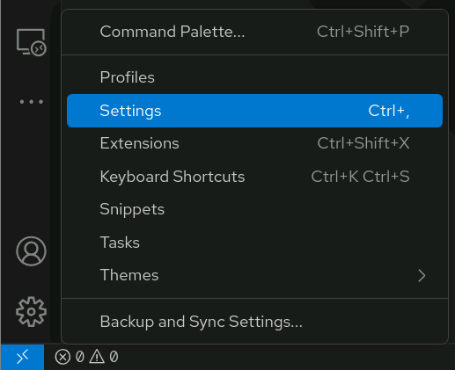
- Filter the Settings
In the search bar, type ansible to filter settings.
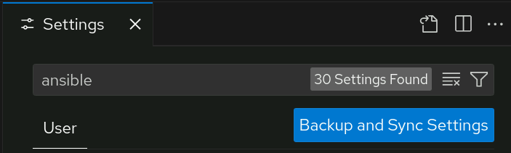
- Enable the Execution Environment
Go to Ansible → Execution Environment, and then select Enabled.
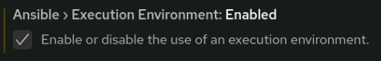
- Select the Container Engine
Go to Ansible → Execution Environment: Container Engine. Select podman as your preferred engine.
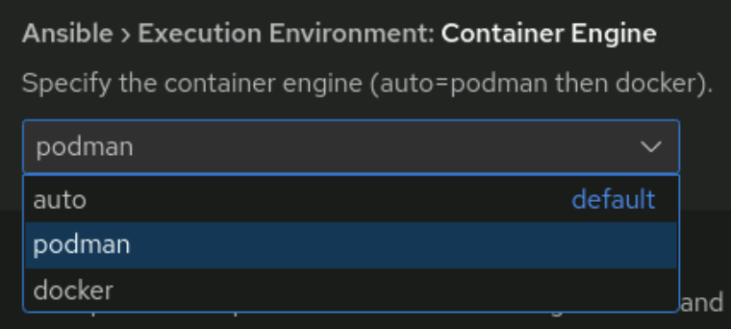
- Define the Execution Environment Image
Go to Ansible → Execution Environment: Image. Enter utility.lab.example.com:5000/ansible-automation-platform-25/ee-supported-rhel8:latest in the text box.
- Set Image Pull Arguments
Go to Ansible → Execution Environment: Pull Arguments. Enter --tls-verify=false
- Set the Pull Policy
Go to Ansible → Execution Environment: Pull Policy. Select missing as the pull policy for the container image.
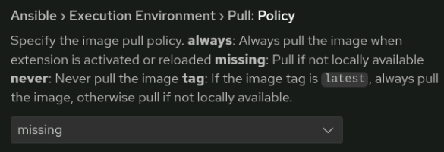
Visual Studio Code uses the defined execution environment to run your playbooks, and if the image needs to be downloaded, it applies the --tls-verify option as configured to pull the container image securely.
References
ssh-keygen(1), and ssh-copy-id(1) man pages
Configuring Ansible: Ansible Documentation
Creating an Automation Content Navigator Settings File: Ansible Documentation
Automation Content Navigator Settings: Ansible Documentation
Reviewing Your Ansible Configuration from Automation Content Navigator: Ansible Documentation

